**1.generation of number series 1,2,3, 4,…n**

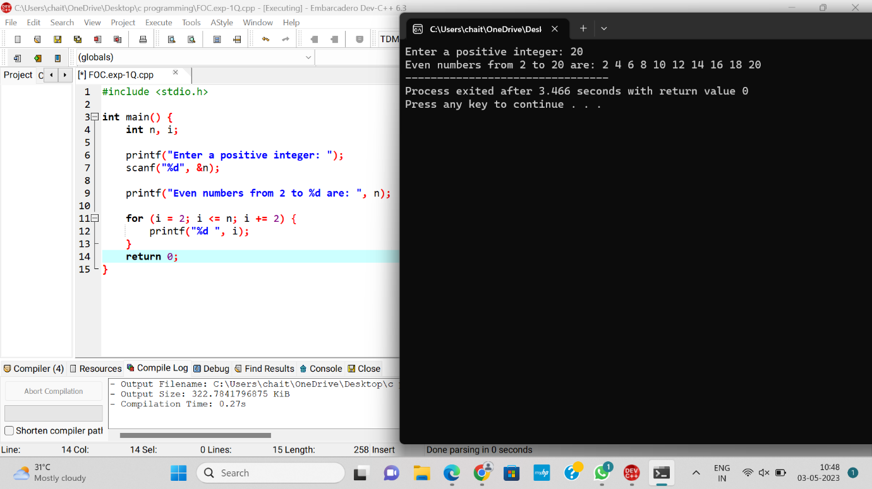

**2. Generation of even number series 2,4, 6, .... n**

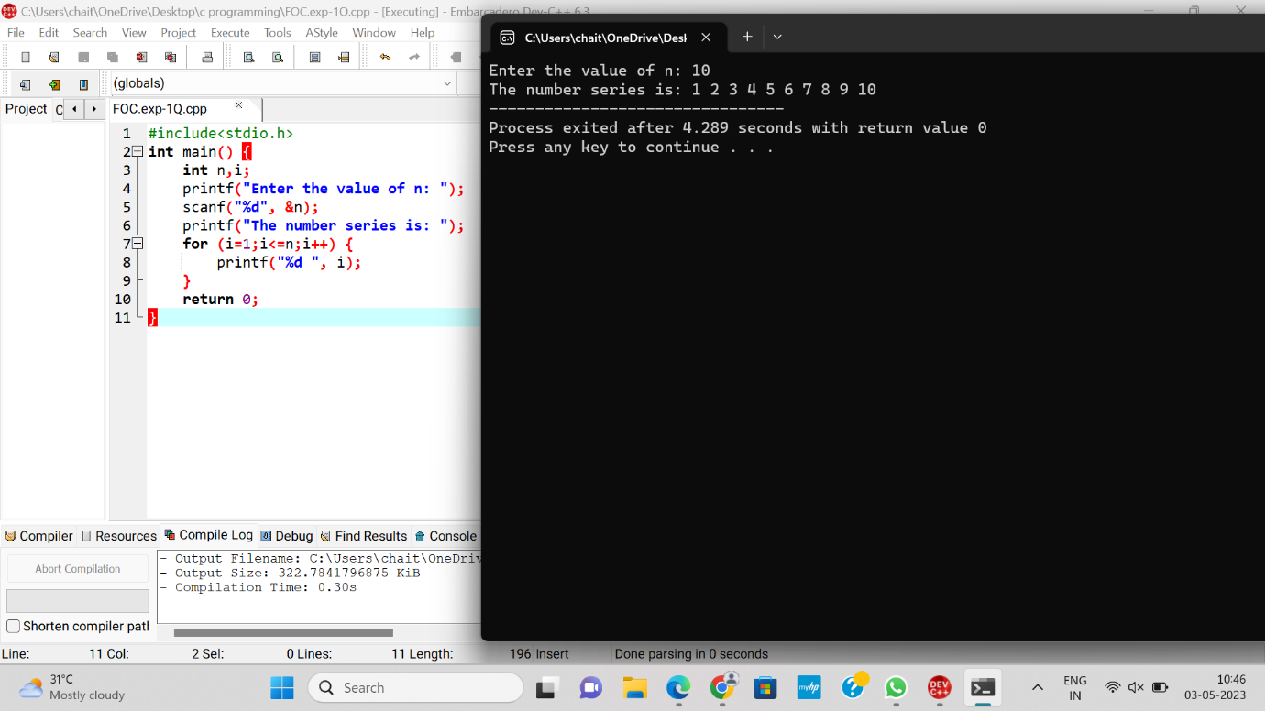

**3. Generation of ODD number series 1,3,5, …n**

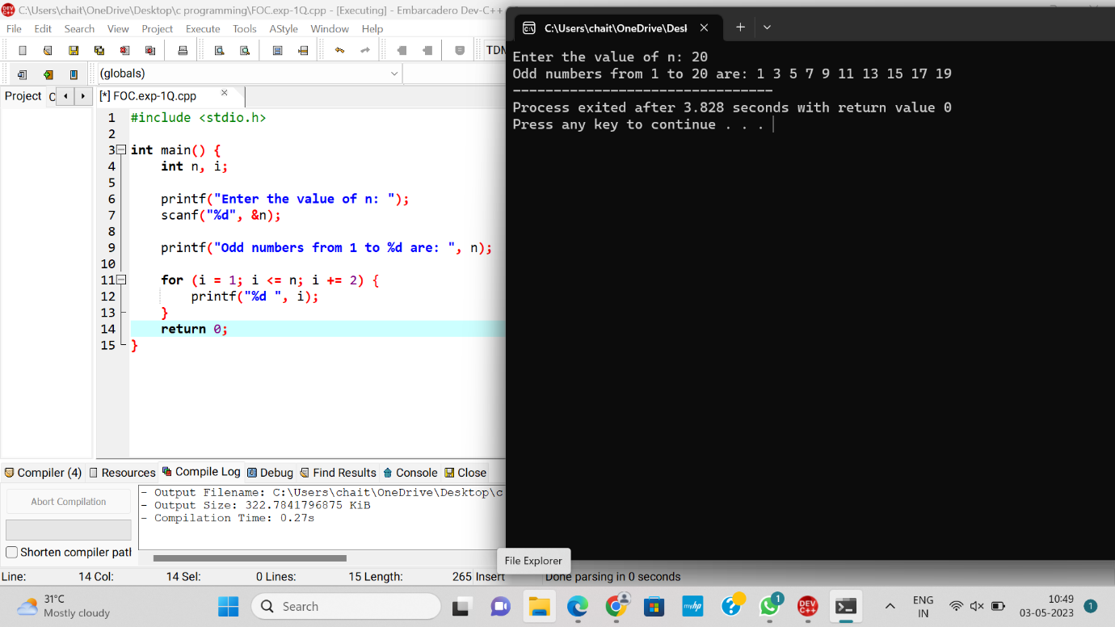

**4. Generations of Fibonacci series 0,1,1,2,3,5, 8, …n**

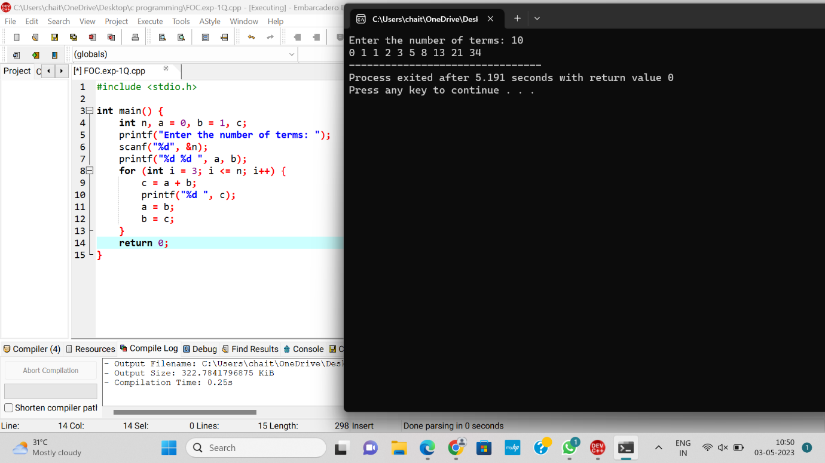

**5. Summing up series 1 + 2 + 3 + 4…. +n**

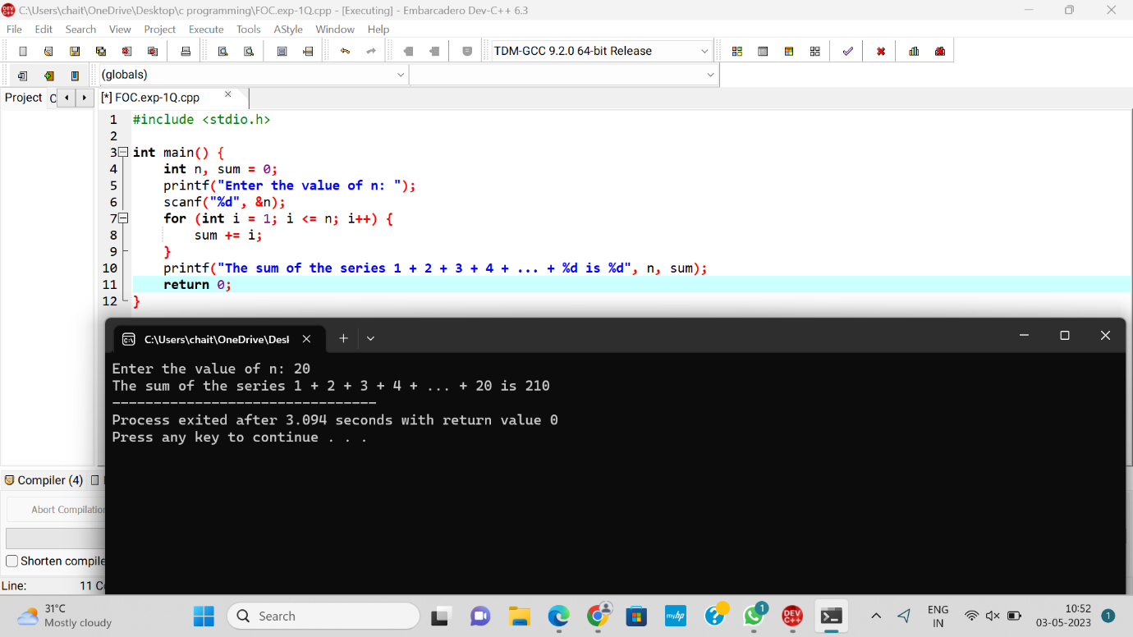

**6. Summing up Even Number series**

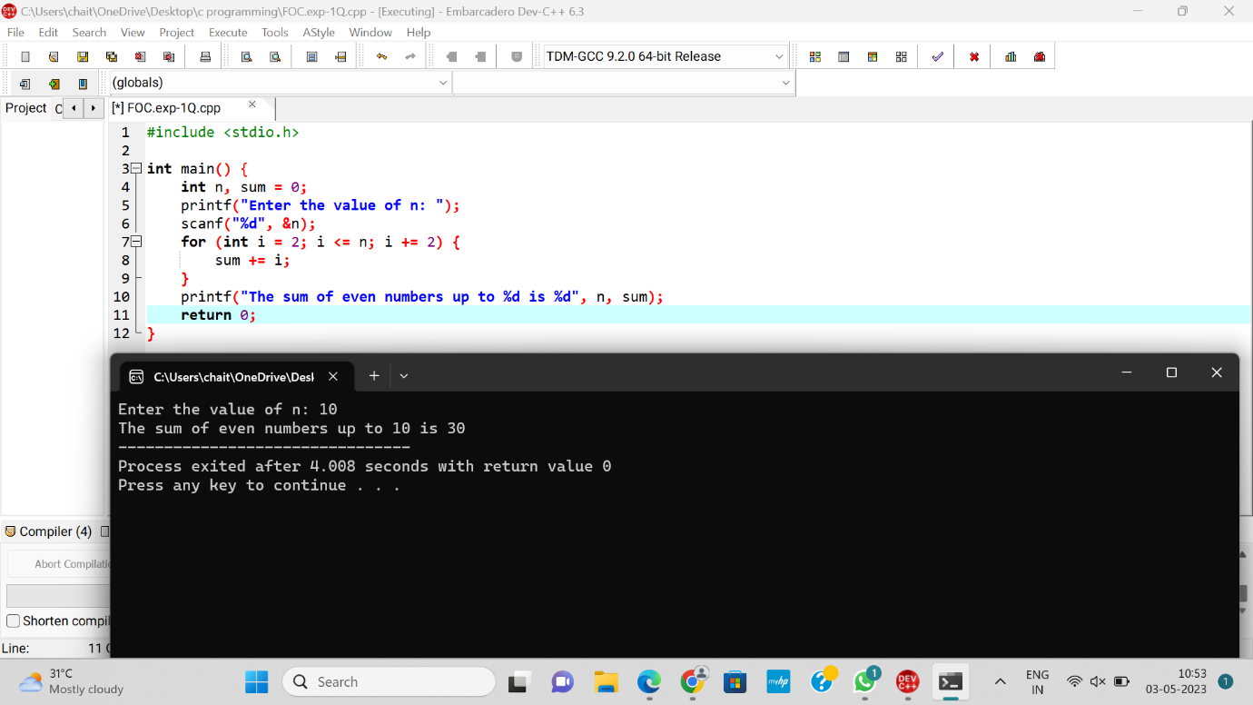

**7. Summing up Odd Number series**

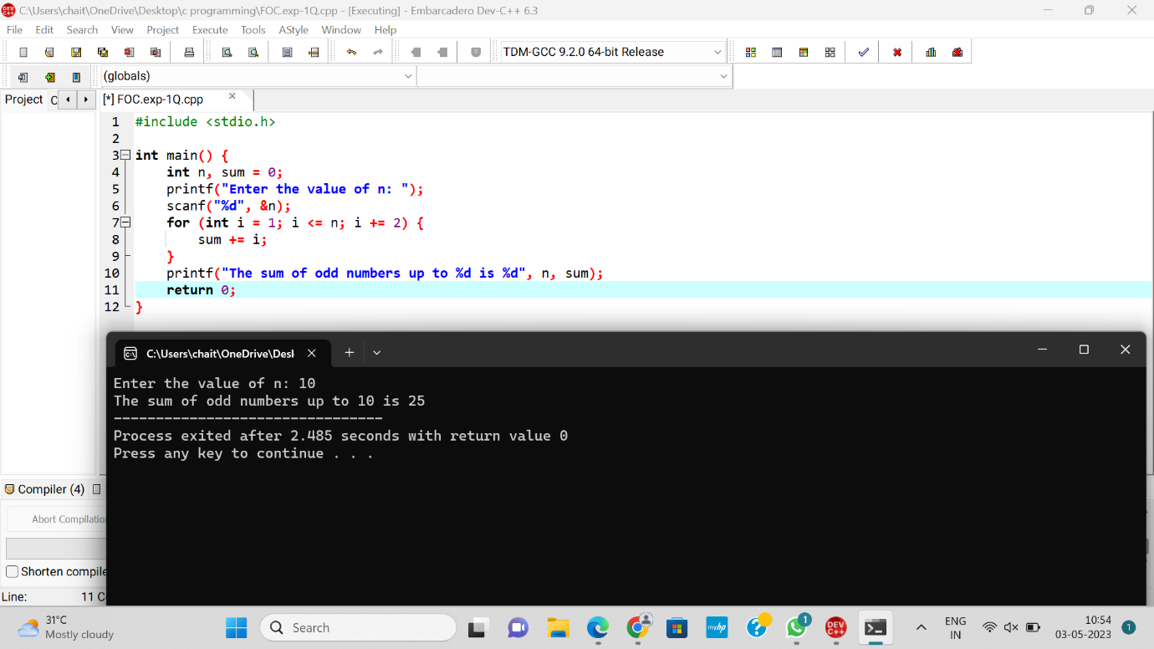

**8. Summing up 1 – 2 + 3 – 4 + 5…. N**

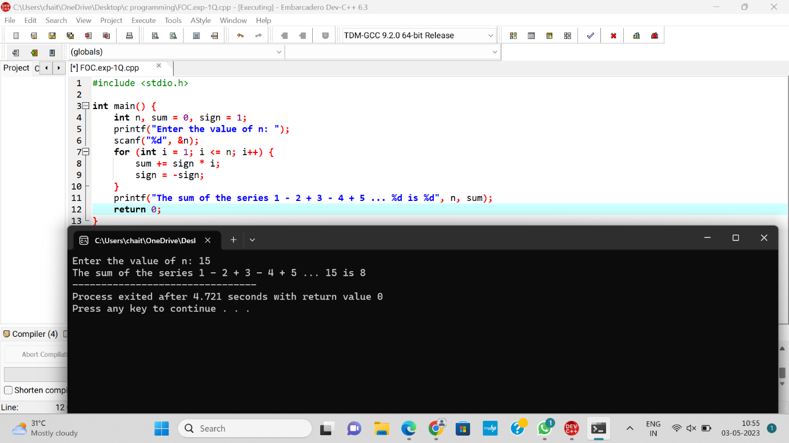

**9. Summing up 12 + 22 + 32 + 42….. +n**

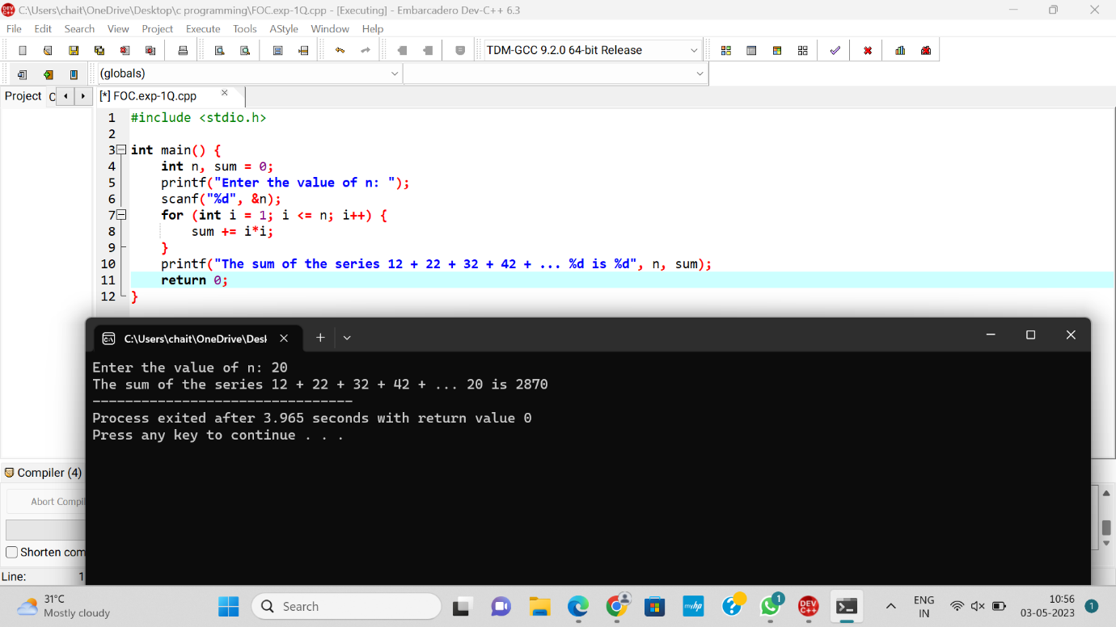

**10. Summing up 22 + 42 + 62 + 82 + ….. n2**

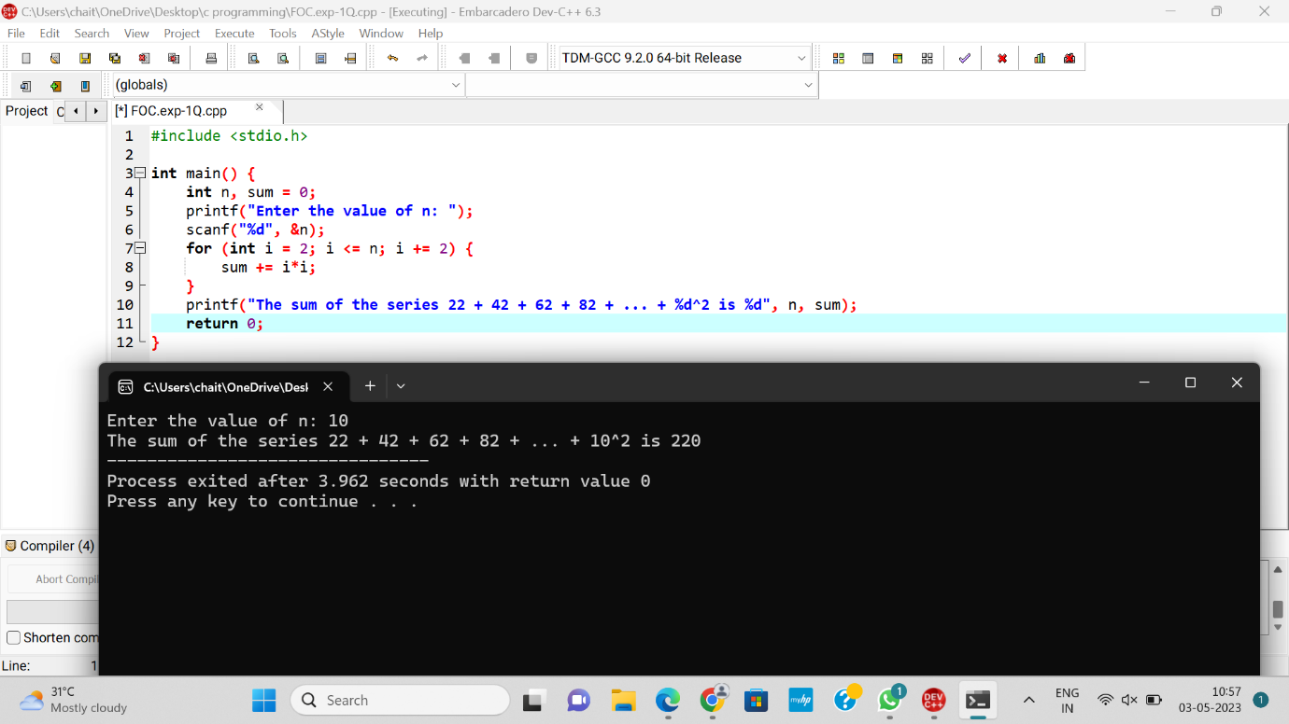

**11. Summing up 11+22+33+44+ …. nn**

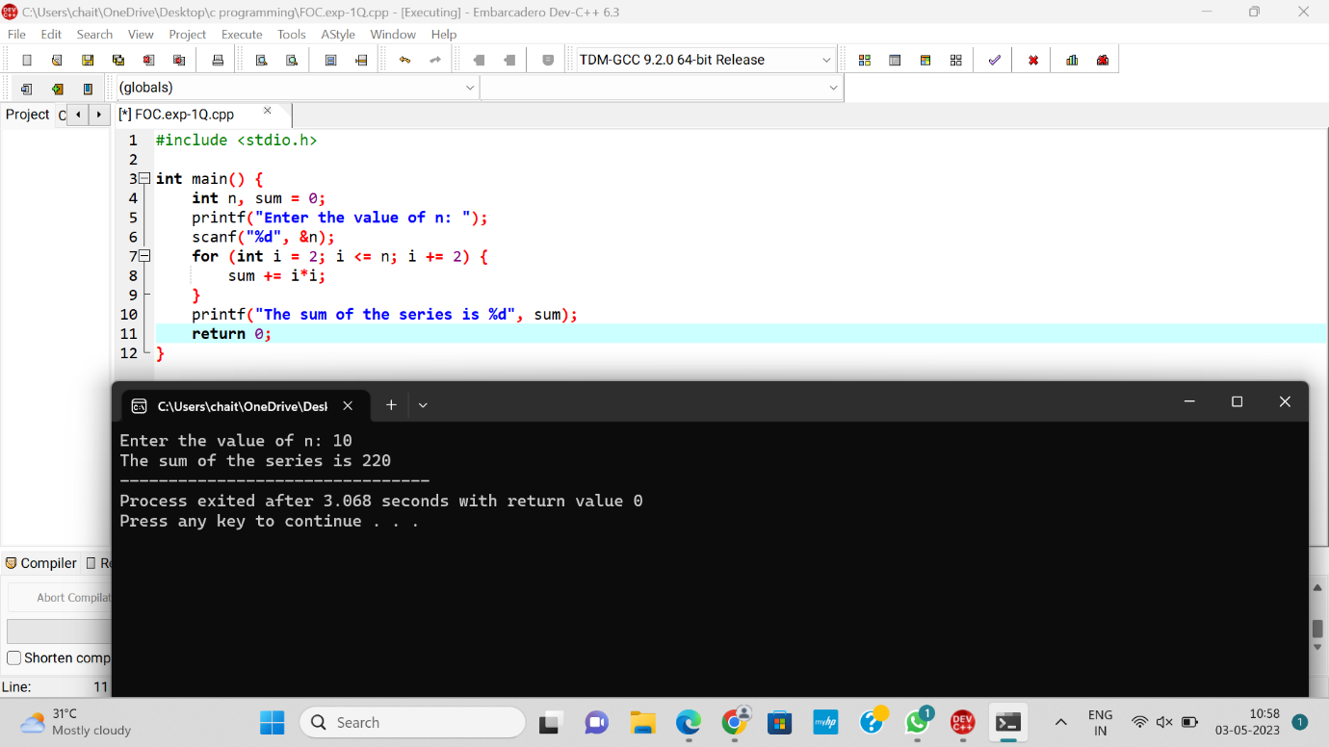

**12. Summing up squares of Odd numbers**

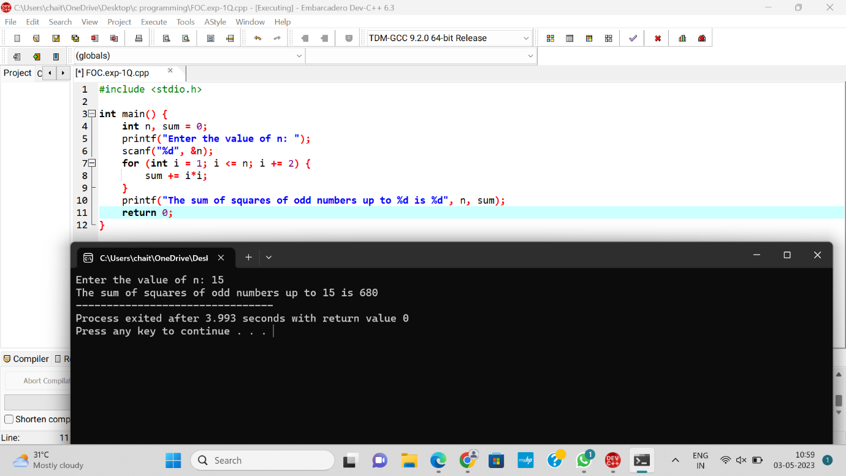

**13. Summing up cubes of n numbers**

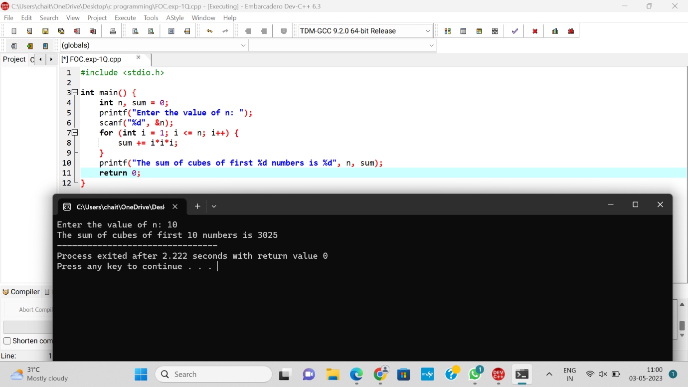

**14. Product series (Factorial of a given number)**

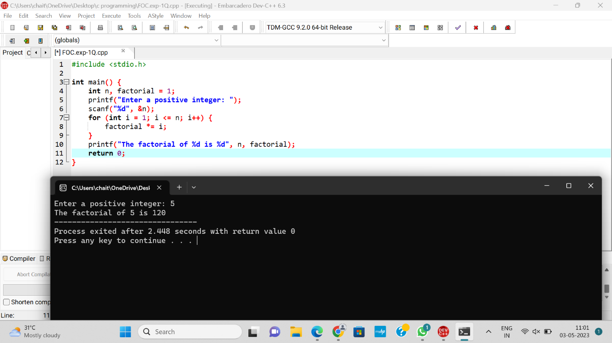

**15. Finding given number is Armstrong or not**

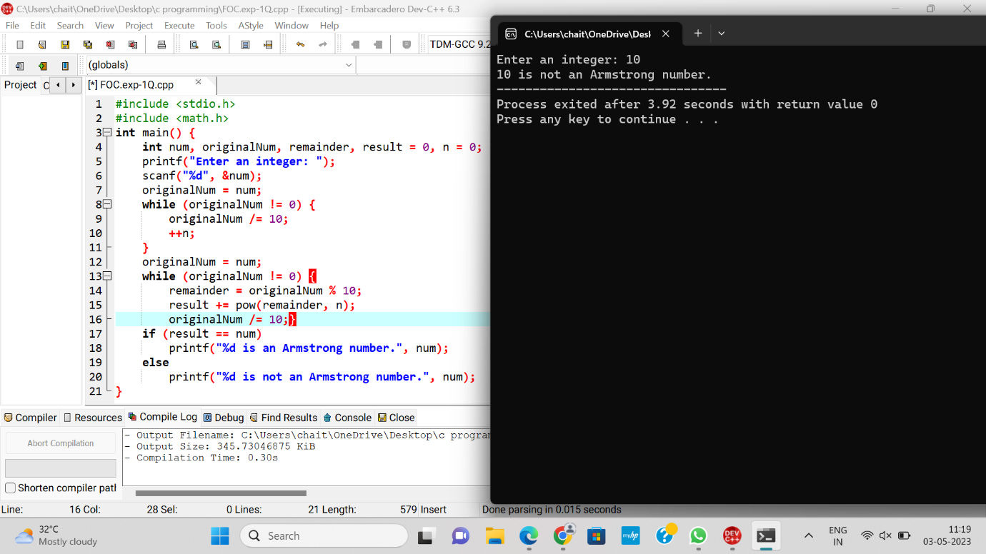

**16. Summing up any n numbers and finding average**

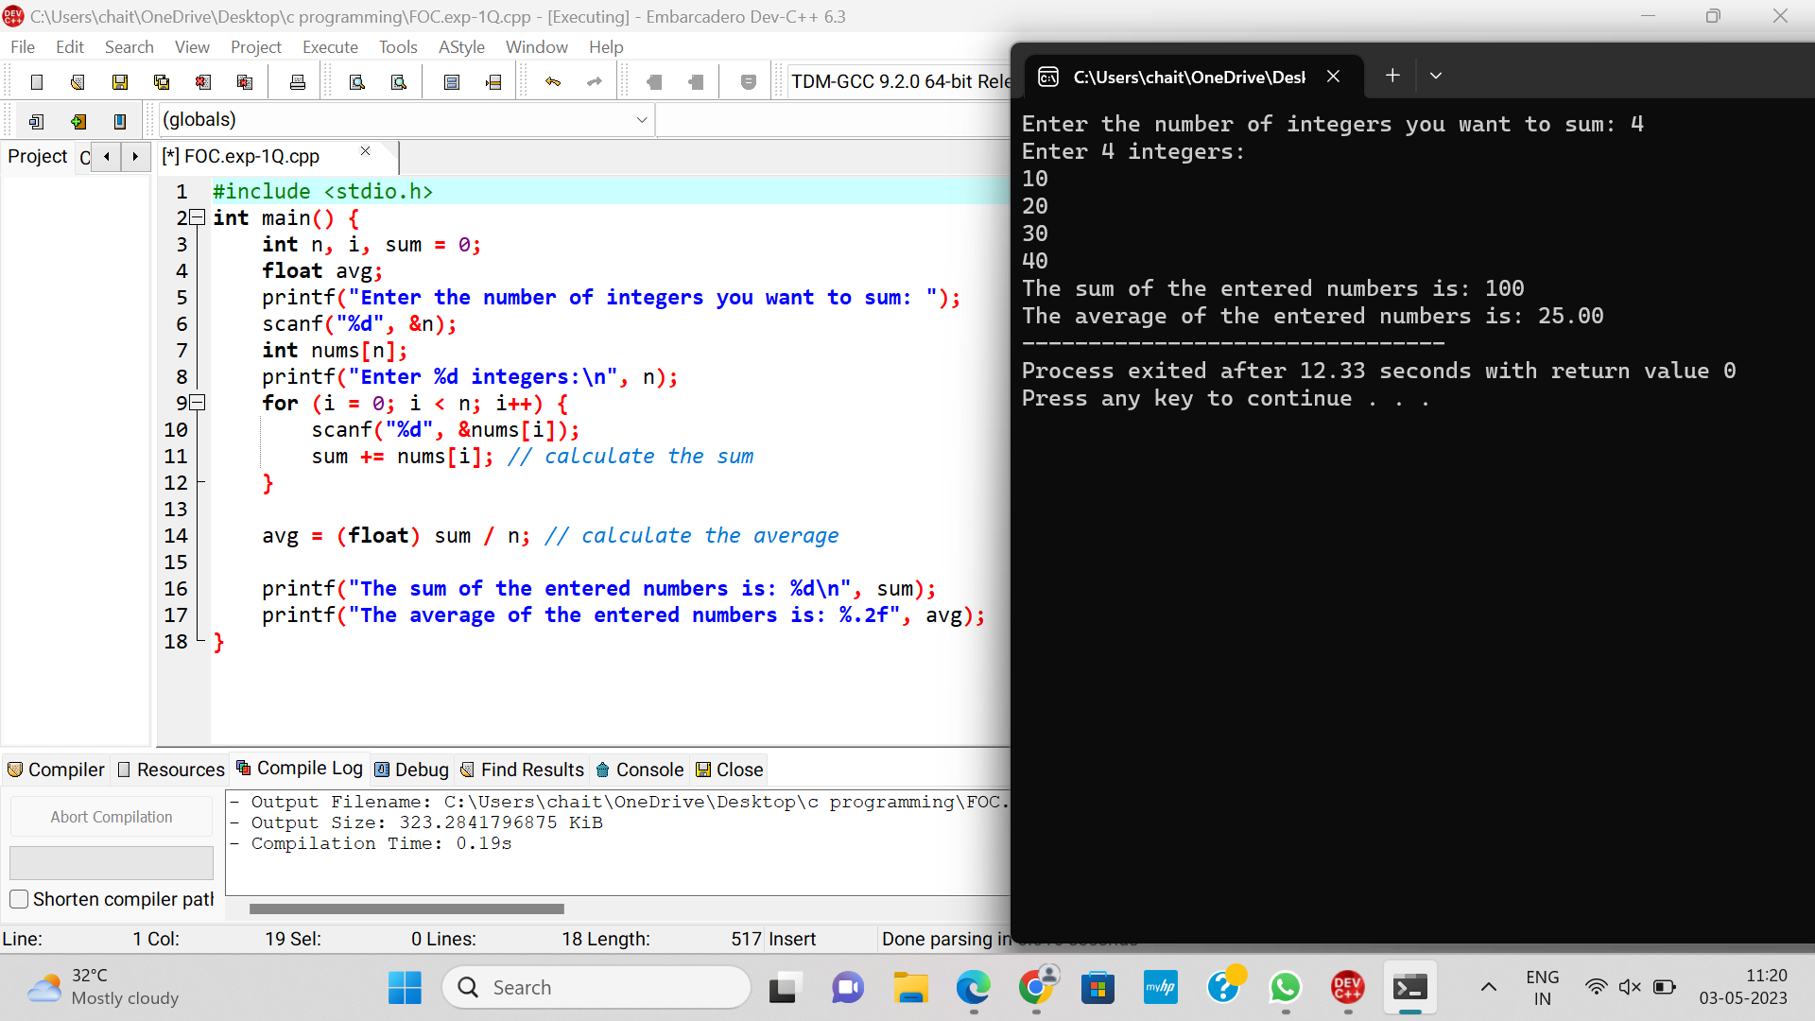

**17. Printing digits of an integer number**

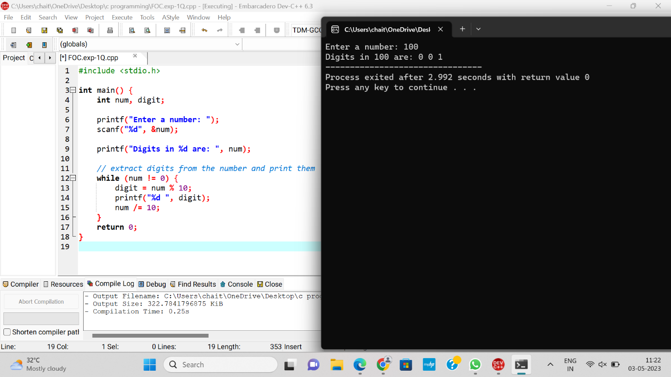

**18. Summing up the digits of an integer number**

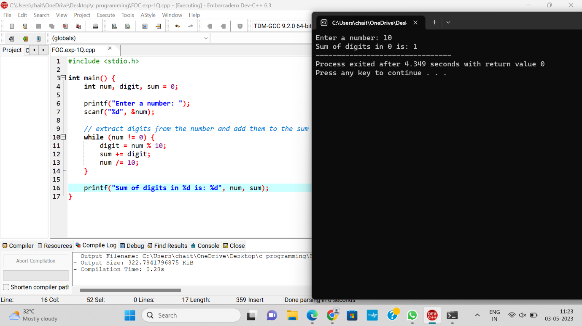

**19. Revering the digits of an integer number**

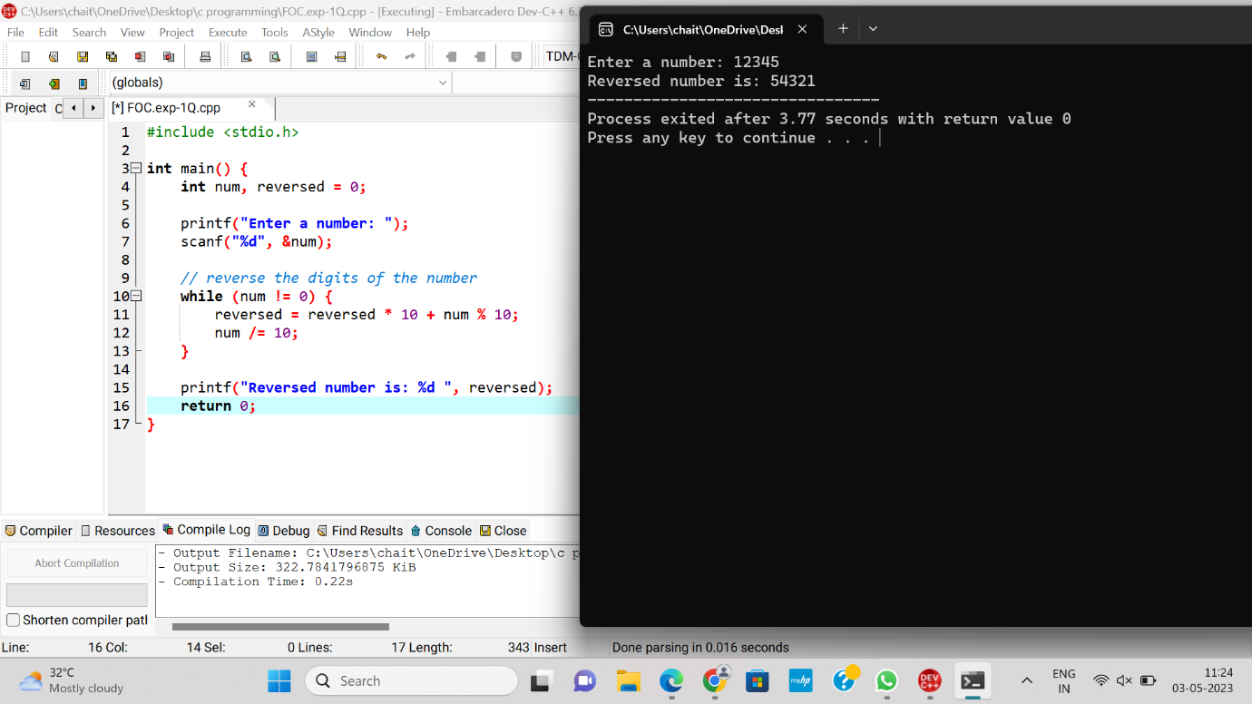

20. Finding whether the given integer is odd or even

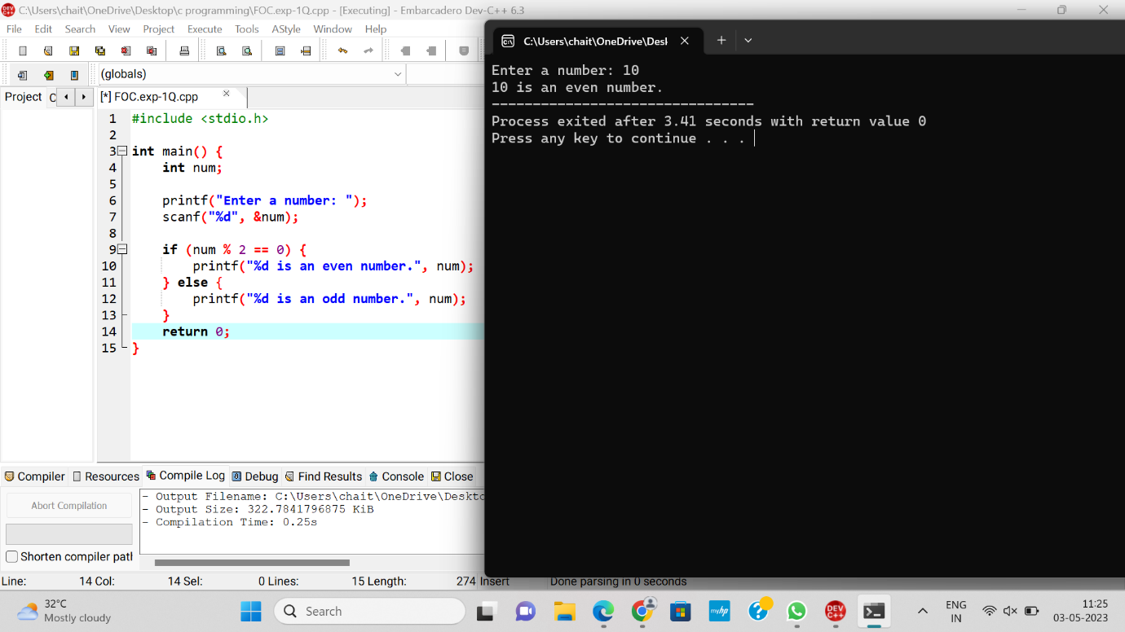

21. Finding the given integer is positive or negative

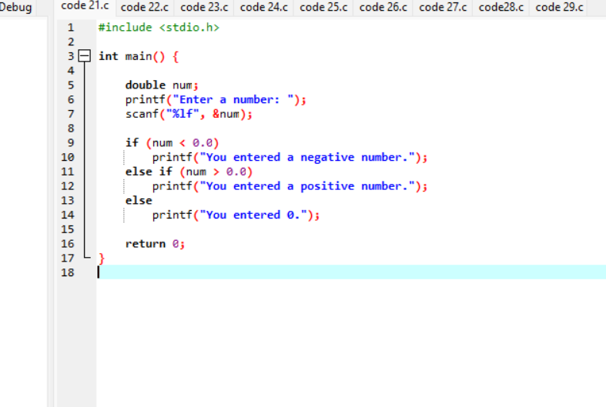

OUT PUT:

Enter a number: 12.3

You entered a positive number

22. Swapping two numbers with a temporary variable

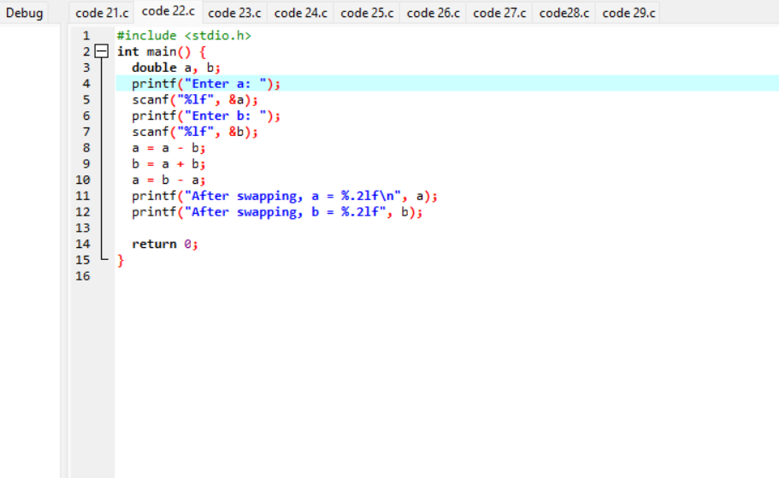

OUT PUT:

Enter a: 10.25

Enter b: -12.5

After swapping, a = -12.50

After swapping, b = 10.25

23. Swapping two numbers without a temporary variable

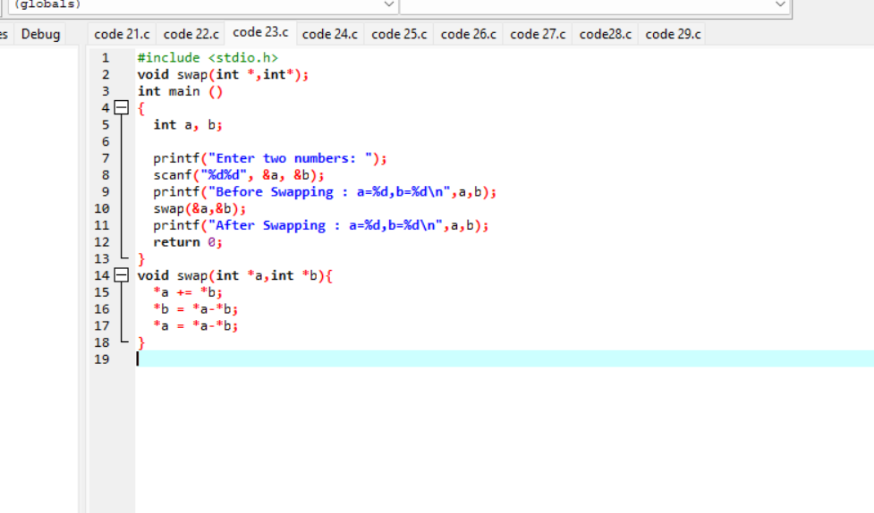

OUT PUT:

Enter two numbers: 1 2

Before Swapping : a=1,b=2

After Swapping : a=2,b=1

24. Swap 3 numbers a to b, b to c and c to a

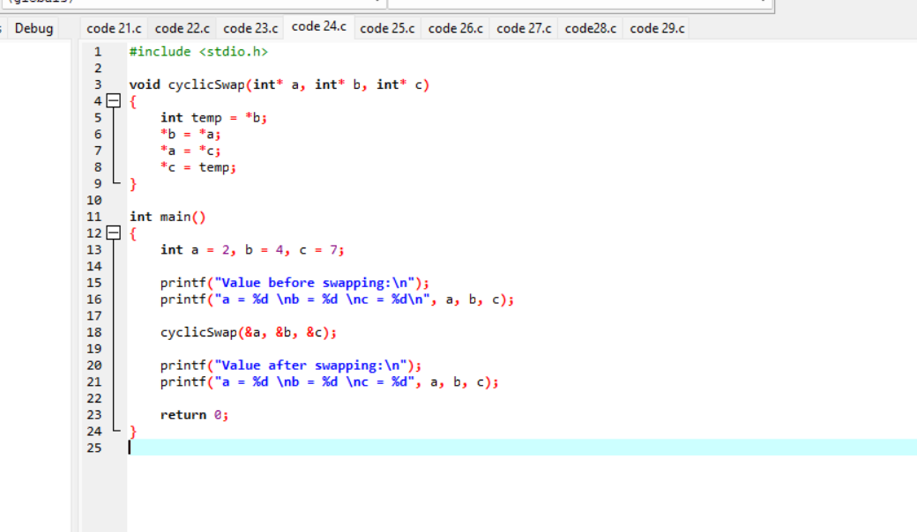

OUT PUT:

Value before swapping:

a = 2

b = 4

c = 7

Value after swapping:

a = 7

b = 2

c = 4

25. Finding the biggest out of 2 integer numbers

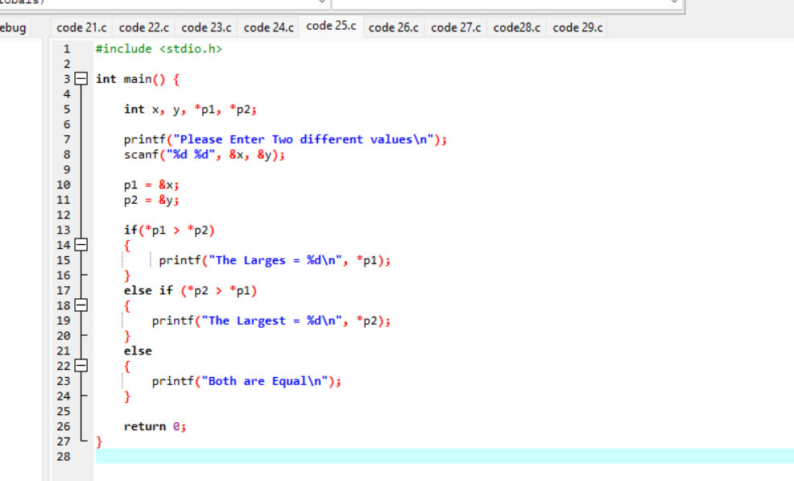

OUT PUT:

Please Enter Two different values

99

15

The Largest = 99

Please Enter Two different values

12

19

The Largest = 19

Please Enter Two different values

15

15 Both are Equal

26. Finding the biggest out of n integers

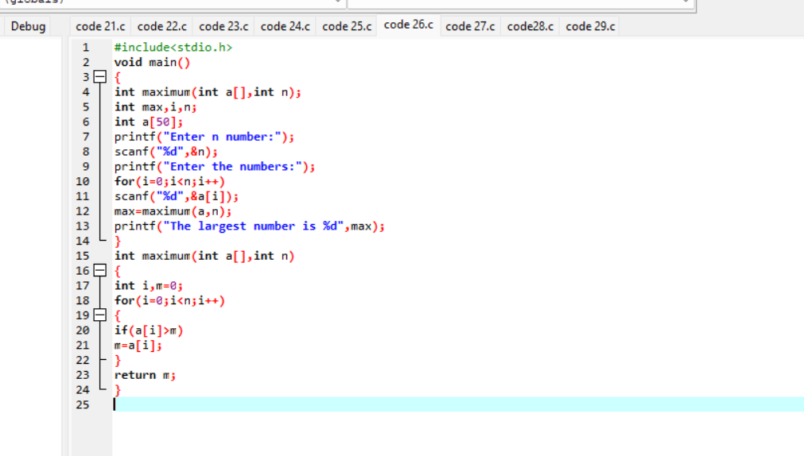

27. Sine series [sin(x) = x - x 3 /3! + x 5 /5! - x 7 /7! . . . . . .]

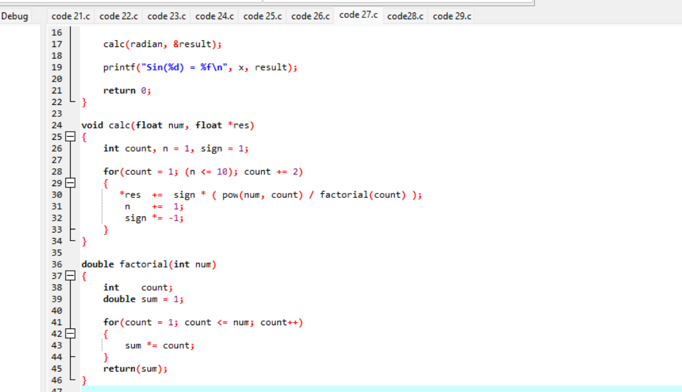

OUT PUT:

Enter value of x is degrees  
0  
Sin(0) = 0.000000

28. Cos series [cos(x) = 1 – x 2 /2! + x 4 /4! – x 6 /6! . . . . . . ]

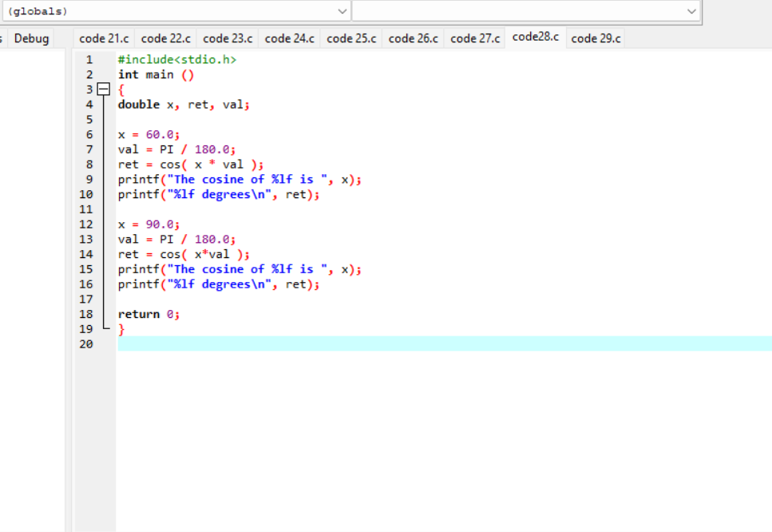

OUT PUT:

The cosine of 60.000000 is 0.500000 degrees

The cosine of 90.000000 is 0.000000 degrees

29. Exponential series [e -1 = 1 – x/1! + x 2 /2! – x 3 /3! + x4 /4! . . . . . .]

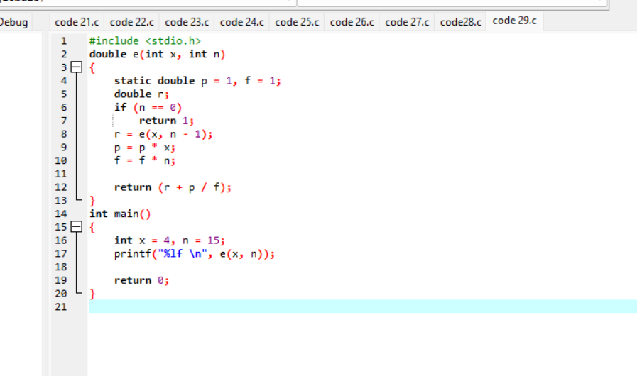

OUT PUT:

54.597883